Directions for the Teacher:
Cut out the 14 histograms, and post them around the perimeter of your classroom.
Your students should have a pencil, a folder or other solid writing surface, and piece of notebook paper, numbered 1-14.
Place one or two students at each station.
Use a timer to give students the same amount of time at each station.
Students should read the question, interpret the data display, and record their answers next to the corresponding number on their papers.
Students should not proceed to the next station until you give the signal.
There are two keys provided. One key includes the original histograms and questions, and the other key is a simple, numbered list, intended for a quick check.

Thanks for your purchase!
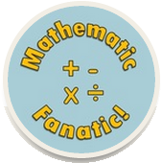
#2
#1

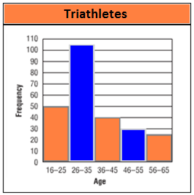
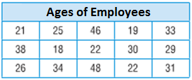

If you made a histogram with this data, what would the frequency be for the interval 20 – 29?

How many runners were less than 36 years old?

#4
#3

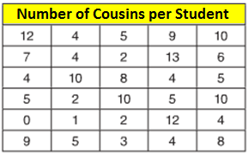
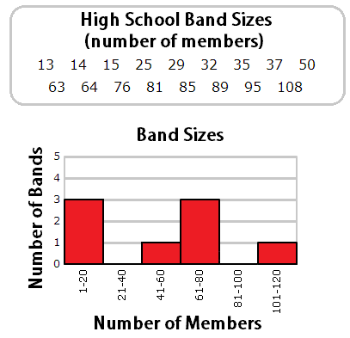

If you made a histogram with this data, what would the frequency be for the interval 0 – 2?

This histogram is not finished. How many bands should be represented in the 81-100 interval?

#6
#5

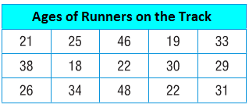
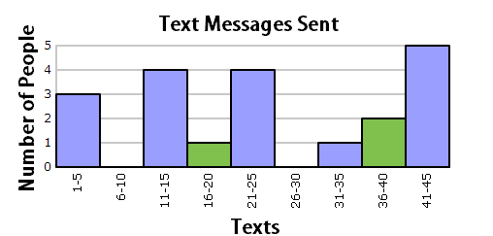
How many runners were older than 35?

How many people sent more than 30 text messages?
How many people sent 31 or more text messages?

#8

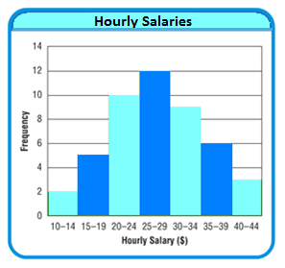
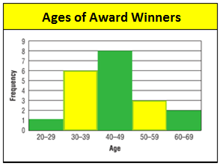
#7
#7

Based on the data in the histogram, do you know how many winners were exactly 30 years old? Explain your answer.
How many hourly salaries were between $15 and $24?

#10
#9

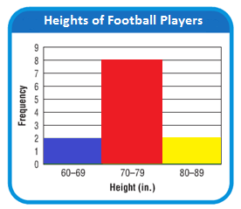
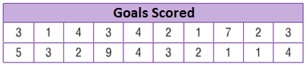

What would be a few appropriate intervals for this data?

Would you describe the histogram as symmetrical or skewed?

#12
#11

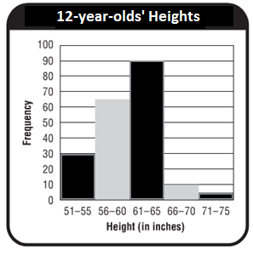
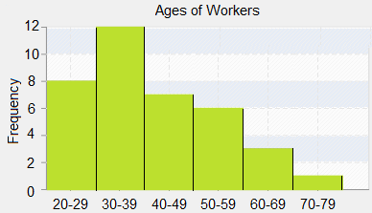

Would you describe the histogram as symmetrical or skewed?
How many more 12-year-olds were in the 61-65 inch interval, compared to the 51-55 inch interval?

#13
#14

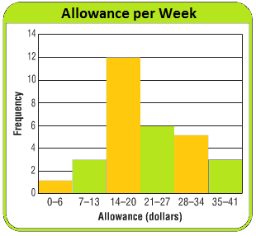
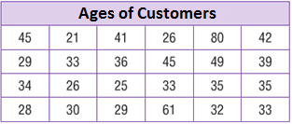
How many kids earned an allowance greater than $6 per week?
According to the table, how many customers were there?

Key
#1
#2



If you made a histogram with this data, what would the frequency be for the interval 20 – 29? 6

How many runners were less than 36 years old? 155 runners

#3
#4




If you made a histogram with this data, what would the frequency be for the interval 0 – 2? 5

This histogram is not finished. How many bands should be represented in the 81-100 interval? 4 bands

#6
#5




How many runners were older than 35? 3 runners
How many people sent more than 30 text messages? 8 people

#8



#7
#7

Based on the data in the histogram, do you know how many winners were exactly 30 years old? Explain your answer. No, everyone in their 30’s is grouped together.

How many hourly salaries were between $15 and $24? 15 salaries

#10
#9




What would be a few appropriate intervals for this data? Answers will vary. Be sure intervals are consistent. Possibilities include: 0-2, 3-5, 6-8
Or 1-3, 4-6, 7-9, etc.

Would you describe the histogram as symmetrical or skewed? symmetrical

#12
#11




Would you describe the histogram as symmetrical or skewed? skewed
How many more 12-year-olds were in the 61-65 inch interval, compared to the 51-55 inch interval? 60 more

#14
#13



According to the table, how many customers were there? 24 customers
How many kids earned an allowance greater than $6 per week? 29 kids
Key
- 155 runners
- 6
- 4 bands
- 5
- 8 people
- 3 runners
- No, everyone in their 30’s is grouped together.
- 15 salaries
- Symmetrical
- Answers will vary. Be sure that the intervals are
consistent. 0-2, 3-5, 6-8 or 1-3, 4-6, 7-9 etc.
- Skewed
- 60 more
- 24 customers
- 29 kids

